Basic navigation and symbols cheat sheet 🡪 

Controlling CO cheat sheet 🡪 

Finance FI cheat sheet 🡪 

Fiori cheat sheet 🡪 

ABAP cheat sheet 🡪 

SD cheat sheet 🡪 

MM cheat sheet 🡪 

* More information about Hana in-memory OLAP/OLTP by Hasso Plattner 🡪 <http://s-prs.co/v485708>

**t-codes used in ECC which are deprecated in S/4 Hana**

t-code SE16 table PRGN_CORR2 – on the left deprecated.

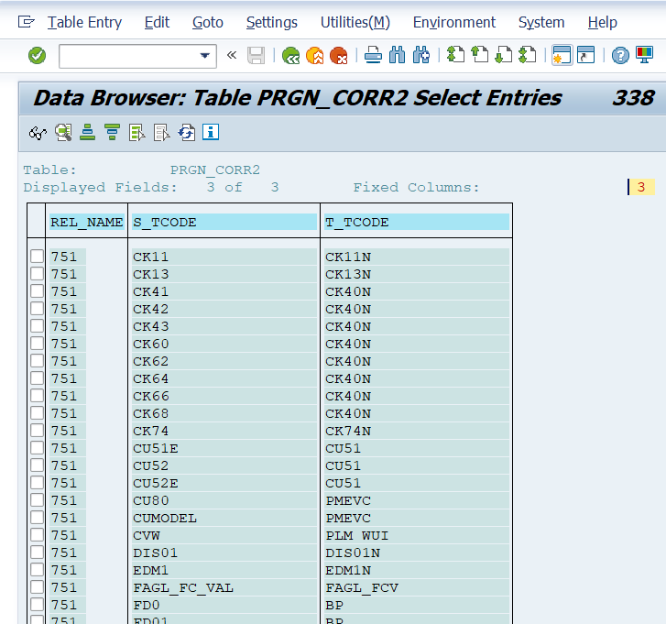

Parameters to use in t-code SU3

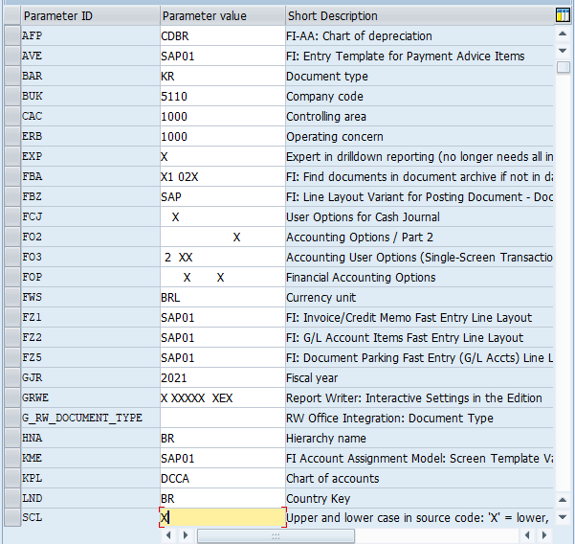

Fiori Apps List

[SAP Fiori List](https://fioriappslibrary.hana.ondemand.com/sap/fix/externalViewer/)

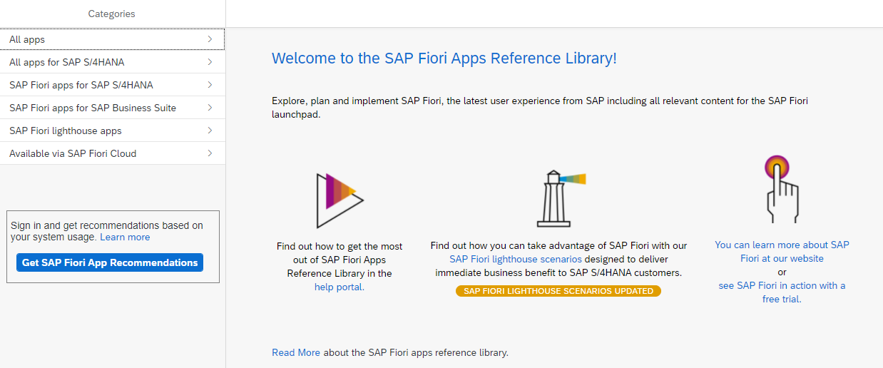

**Activities IMG – Transactions Configuration Tree**

ORFA – Asset Accounting

FAGL_FLEXGL_IMG – Financial Accounting

GLFLEXIMG – New GL

FOAR00 – Task Menu

SUIM – User Information System

* Go to table TSTC and on field Program = *IMG* for consultants
* Go to table TSTC and on field Program = *menu* for users
* Another way is table TSTCT (transactions text) and table TSTCP (transactions parameters) where can be search by t-code SM30 or by table.
* To create your own Menu Are go to t-code SE43 – Search for *00* *MN* for more t-codes

**User Menus**

SAP1 – All reports

ASMN – Asset Accounting

FIAA – Asset Accounting Information

FDMN – Customer Accounting

FKMN – Vendors Accounting

F000 –Financial Accounting ]

ORK0 – General Controlling

ORKL – Cost and Revenue Element Accounting Controlling

FGM0 – Special Purpose Ledger

CKML – Actual Costing / Material Ledger

FGRW – Report Writer

SISU – Industrial Solution – Utilities

PC37 – Payroll Brazil

Questions for a new SAP project or enhancement

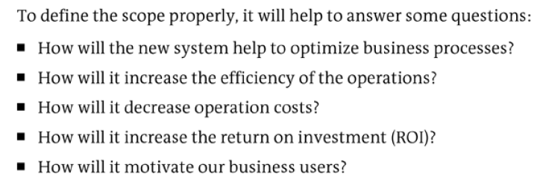

Pros and Cons – Project S/4Hana

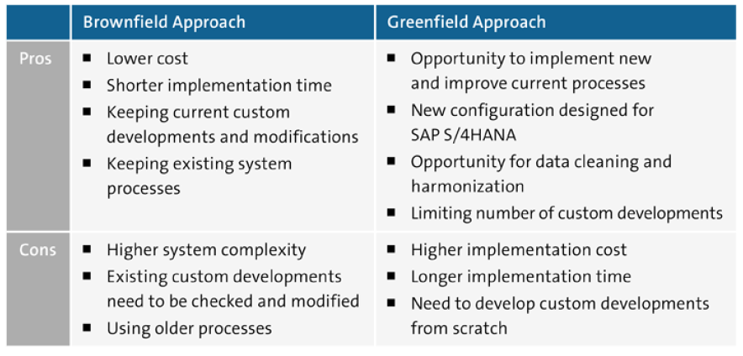

Table ACDOCA

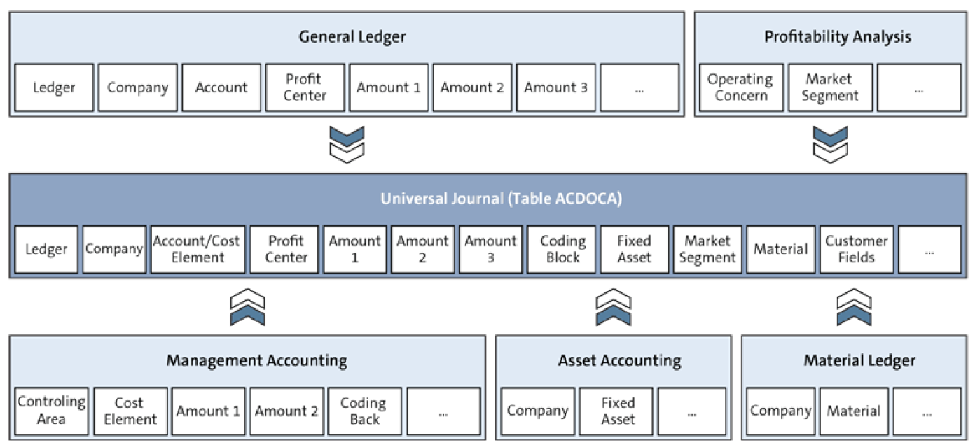

Obsolete tables – exist in S/4Hana only for compatibility reasons as CDS views (core data services)

